**Query 1**

Find each active user who reviewed at least 3 different restaurants in the last 90 days, and return their most liked review during that period. For each review, include the review text, number of likes, score, date, the restaurant's name and location (latitude and longitude), and the user's name.

**Unoptimized Version**

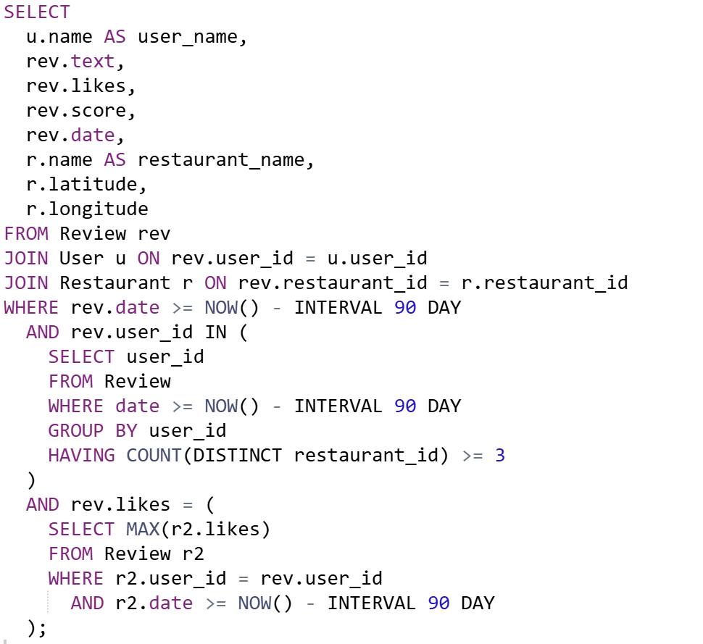

**Optimized Version**

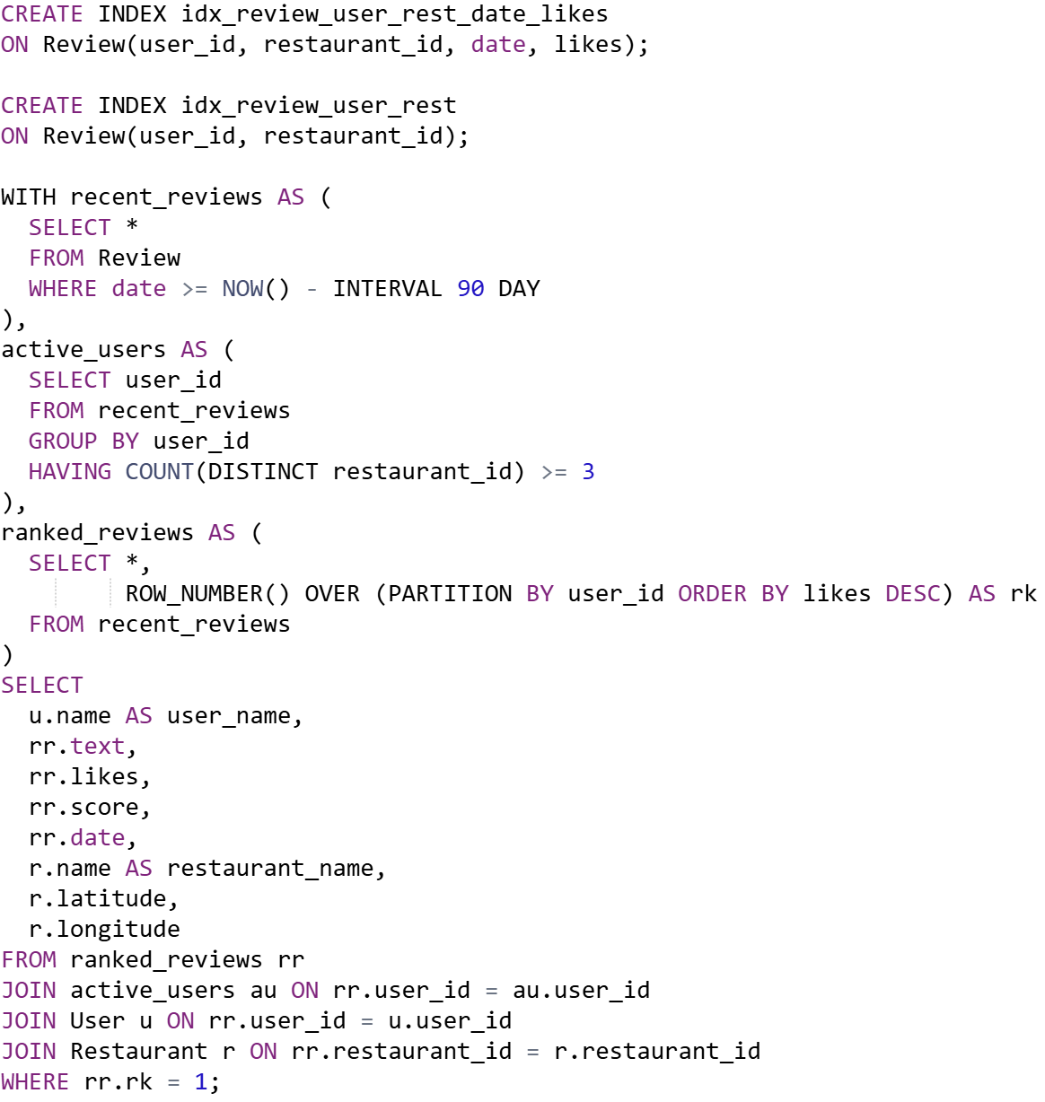

**Query 2**

For each dish category, calculate the average score and the price range (minimum and maximum) of all dishes in that category. Then, identify specific dishes whose price is at least 20% higher than the category’s average price and whose associated reviews have a score greater than 4. For each of these dishes, include the dish name, price, score, the name of the restaurant offering it, and the restaurant's geographic location (latitude and longitude).

**Unoptimized Version**

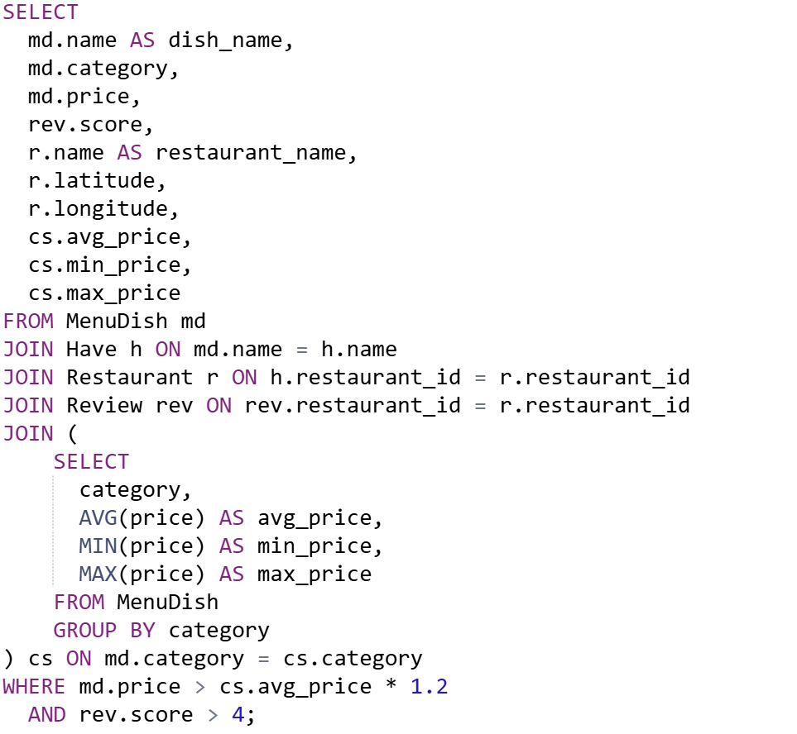

**Optimized Version**

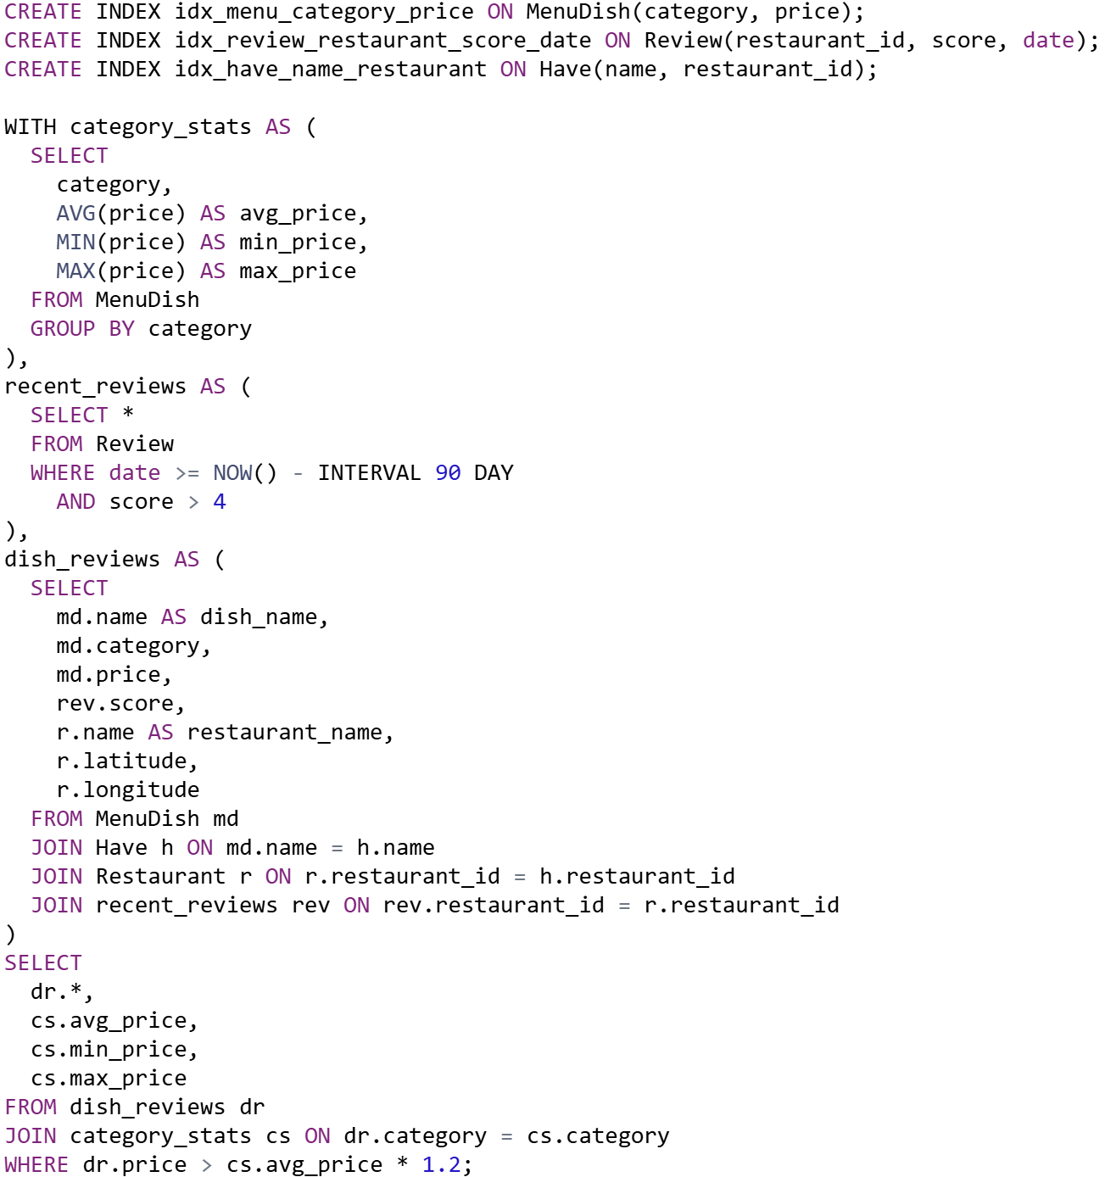

**Query 3**

Find the top 5 restaurants with the highest number of reviews in the past 90 days, considering only those that serve at least 20 different dishes. For each restaurant, return its name, geographic location (latitude and longitude), the total number of reviews during that period, the average review score, the number of unique users who reviewed it, and the number of distinct dishes offered.

**Unoptimized Version**

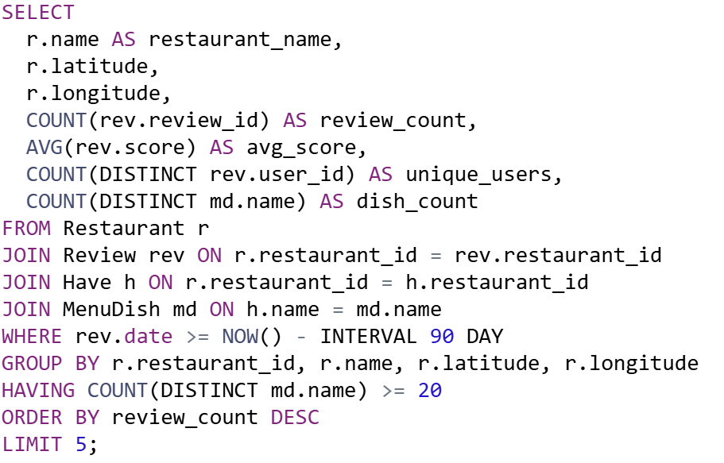

**Optimized Version**

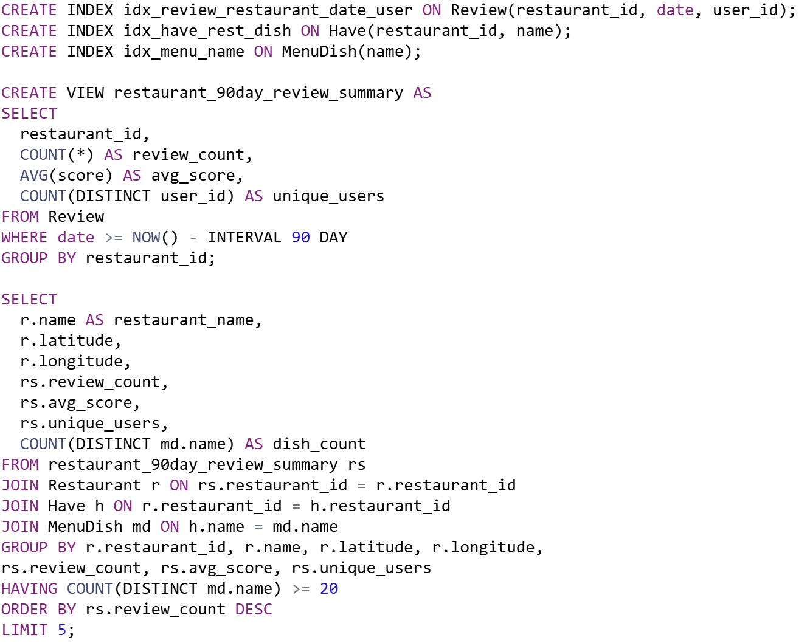

**Query 4**

For each user, find their highest-rated restaurant. Then, among the dishes they have reviewed at that restaurant, return those that belong to the most common dish category served by that restaurant.

**Unoptimized Version**

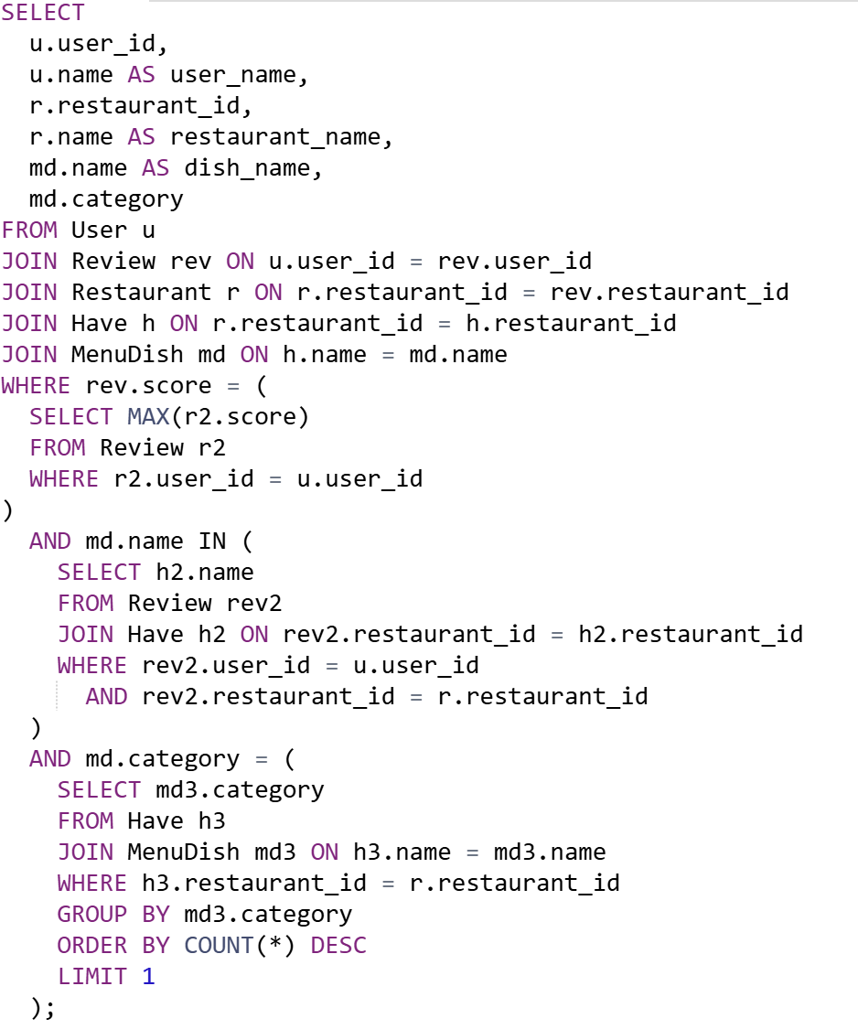

**Optimized Version**

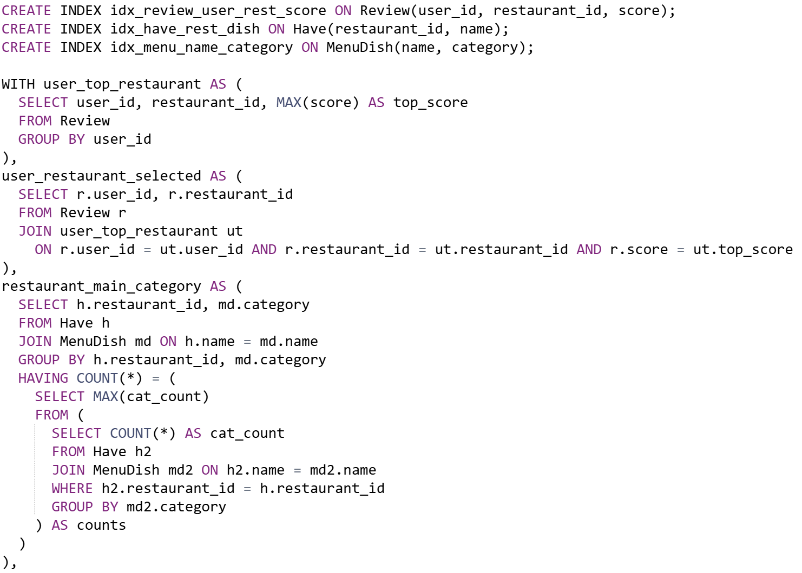 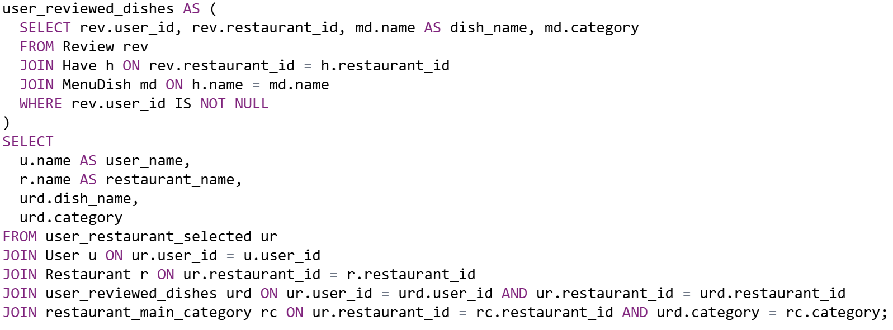

**Query 5**

Find all users who have reviewed every restaurant where a specific dish (e.g., "Spicy Ramen") is served. Return the user ID and name of all users.

**Unoptimized Version**

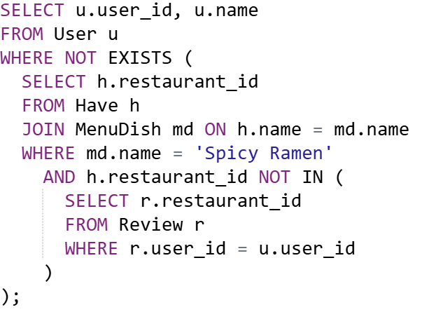

**Optimized Version**

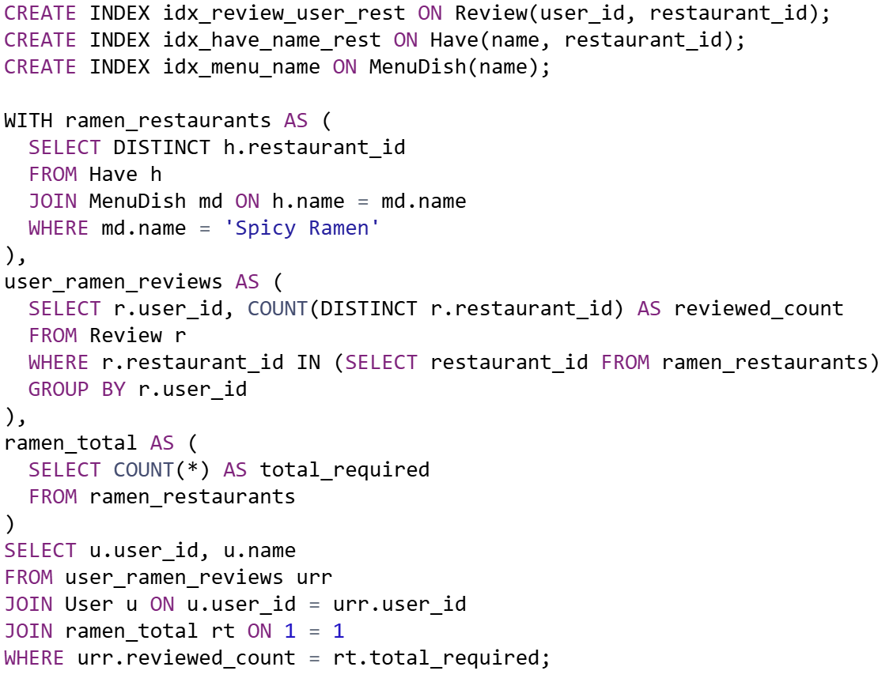

**Query 6**

Find users who have reviewed at least one dish from every category.

**Unoptimized Version**

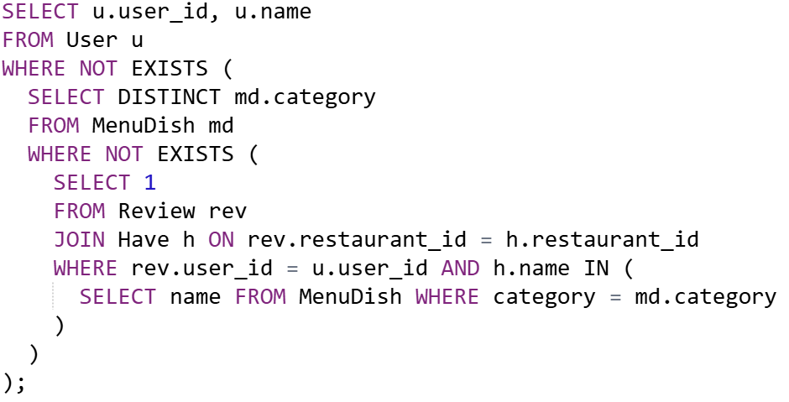

**Optimized Version**

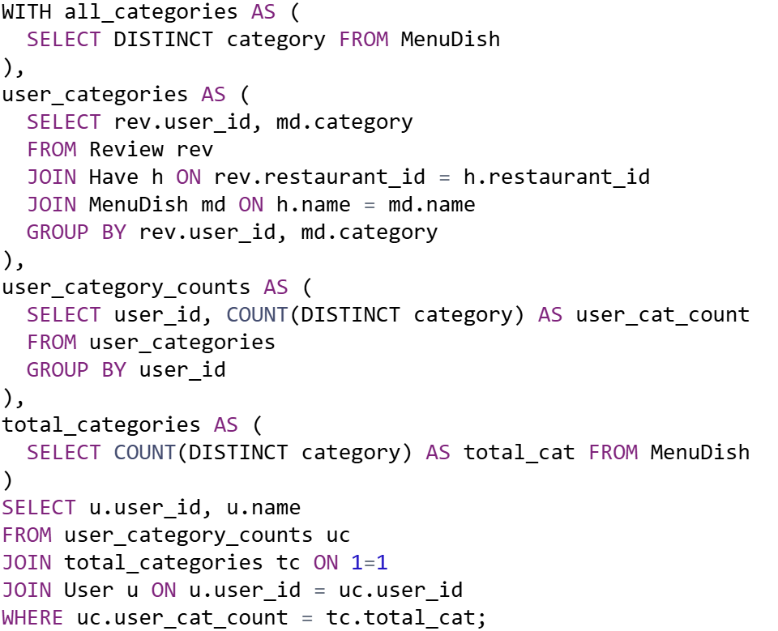

**Query 7**

Identify the top 5 recipes that match the highest number of dishes, with an average review score of at least 4. For each recipe, return the recipe title, the number of such high-rated dishes it is matched to, and the names of those dishes.

**Unoptimized Version**

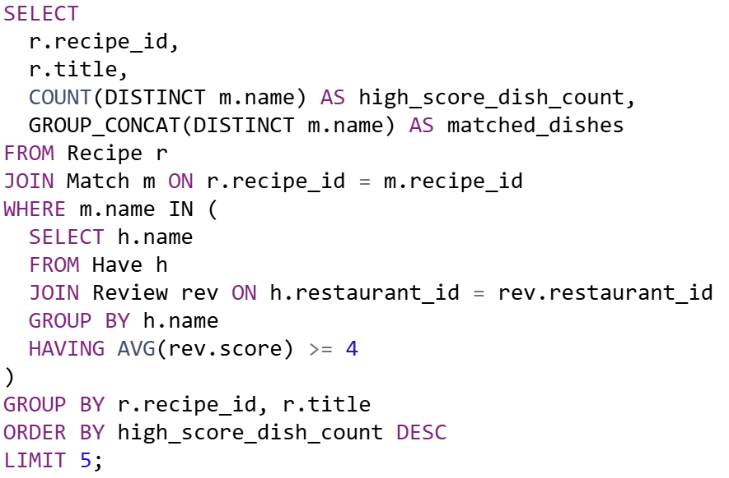

**Optimized Version**

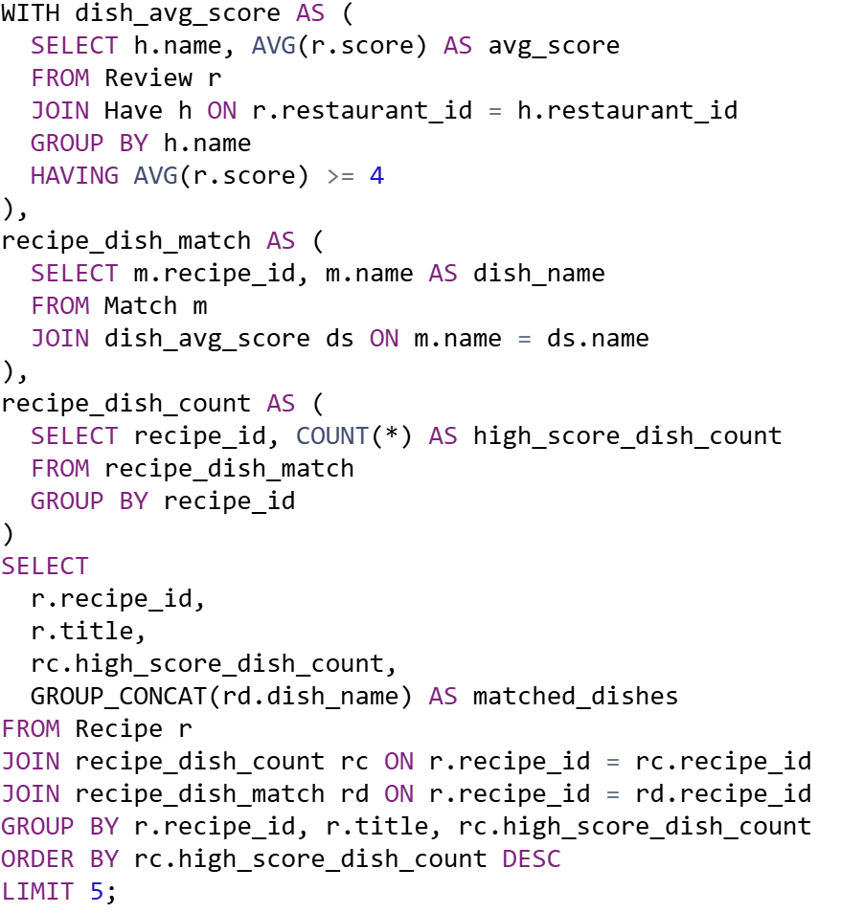

**Query 8**

Find all recipes that are used by restaurants located in at least two different geographic locations. A restaurant is considered to be in a different location if it has a unique combination of latitude and longitude. 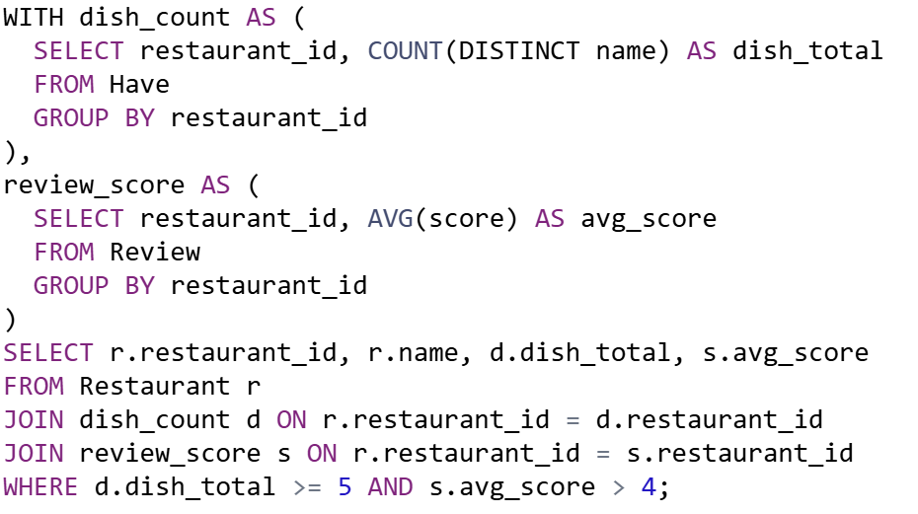

**Query 9**

Find all recipes that are used by restaurants located in at least two different geographic coordinates. For each qualifying recipe, return its recipe ID, title, and the number of distinct geographic locations.

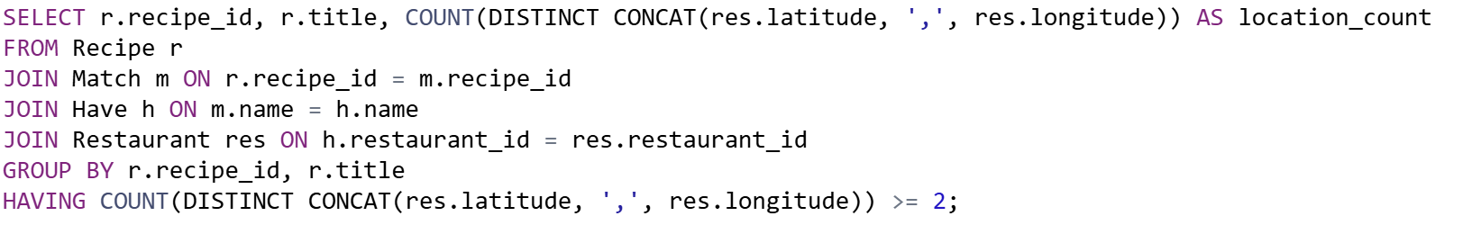

**Query 10**

Find all user–restaurant pairs where the user has at least 2 tags that match the categories of dishes served by the restaurant. For each pair, return the user’s ID and name, the restaurant’s ID and name, and the number of matching categories.

